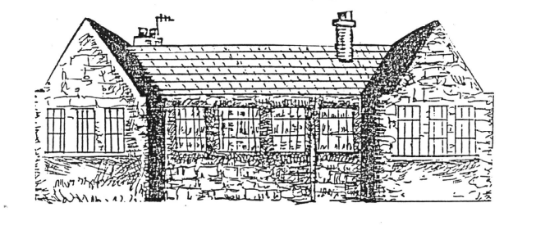Tyrie School

Behaviour Management Policy

Charters/Rules are in place to ensure that all children enjoy a safe and stimulating environment where positive behaviour is promoted and children are encouraged to think of their rights and how to respect the rights of others.

In order to provide a safe, positive environment, staff will:
- Provide positive role models, show consideration, good manners and respect for all children and adults
- Understand stage/age appropriate behaviour
- Make an effort to differentiate between deliberate and accidental occurrences
- Be consistent in the way we approach children; bearing in mind it is better to avoid confrontation.

Children should be treated as individuals and be made aware of the effect their behaviour has on themselves and others, and staff will:
- Praise and encourage good behaviour and ensure that children do not receive adult attention only for undesirable behaviour
- Engage the children in activities, such as circle time, to raise self-esteem and encourage mutual self-respect
- Liaise with parents, staff and HT if a child is in need of behaviour support, if necessary agree an individual action plan
- If necessary, seek parental permission to consult external agencies

School and Classroom Charters should ensure children are aware of their rights and how to respect them. To achieve this staff will:
- Work with pupils to develop a positive set of charters, which establish the rights they are entitled to and how to ensure they respect the rights of others.
- Inform parents, carers and children of the charters and check that they are accepted and understood.
- Deal sensitively with anyone who doesn’t respect their own and others rights.
- Offer fair and consistent treatment to all children.
- Never physically restrain a child unless it is the only practicable way of protecting the child or others. (Parents/carers will always be informed if this has been necessary and written records kept)
- Never ridicule or humiliate children
- Never shout at children in a threatening way
- Make clear to everyone, especially the child, that it is the behaviour that is not acceptable – not the child

Strategies for success in positive behaviour management include rewards and recognition of pupil’s achievements.
These may include:
- Sticker card/stickers/sticker charts/ink stamps
- Star writers badges/displays
- Special mentions at assembly
- Lunchtime and playtime awards
- Own classroom award schemes e.g. moving up a ladder, “dark clouds and sunny smiles, traffic lights,gems ”
- Whole school use of ‘class dojo’ to promote positive attitudes to behaviour and learning
- Circle time
- Communication of classroom achievements with parents
- Star students
- Activity time
- Star Table

The need for approved sanctions and withdrawal of privileges is part of behaviour management also.
These may include:
- Verbal reprimand
- Loss of privileges (including Activity Time/Playtime)
- Loss of points on ‘class dojo’
- Parents contacted by the class teacher or H.T.
- Suspension from school may be effected in serious cases of unacceptable behaviour
- Exclusion from school may also be used in the most serious cases.

At all times staff should make the HT aware of persistent misbehaviour

Policy Updated – September 2015
Next Review Date – August/September 2016

