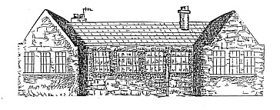
Tyrie Primary School
Vision, Value and Aims

Vision
At Tyrie Primary our school vision is:
- To provide a safe, caring and nurturing environment in which to learn
- To achieve our full potential
- To have the confidence and skills to meet the challenges of the future

Values
Our values guide the way we work.
Together we will:
- Respect and look after each other and the world around us
- Create a challenging, engaging and responsive environment
- Provide a safe, supportive and inclusive community where we value everyone
- Build on the strengths, interests and aspirations of all
- Promote equal opportunities, respect diversity and value the special contribution everyone can make
- Actively encourage and promote health and well being

Aims
- To achieve the best outcomes for each child through partnership between pupils, staff, parents and the wider community.
- To ensure that children feel a sense of achievement in all that they do.
- To celebrate social and cultural diversity so that everyone feels valued and respected.
- To help children to develop a knowledge and understanding of issues affecting their health and wellbeing so that they can make informed choices for their future.
- To enable pupils to become responsible and environmentally aware global citizens.
- To value and celebrate children’s contributions to society.
- To encourage pupils to maintain high standards of behaviour at all times.
- To develop enquiring minds, enterprising skills and embrace lifelong learning.
Updated
Nov 2015

